2026 SACSCOC SUMMER INSTITUTE
Executive Summary
Activity 1: AI Use-Case Prioritization
Session date: July 20, 2026 | 22 table groups | 86 use-case entries

Executive Summary
- Participants converged on mission-facing, practical applications. Assessment, accreditation and outcomes (19 entries) and data, analytics and strategic planning (16) account for 35 of the 86 ideas. Assessment-related ideas appeared across 14 of 22 table groups, the broadest reach of any theme.
- The strongest signal is a portfolio, not a single enterprise bet. Nineteen entries were explicitly marked as a top priority; seven were in data/analytics/planning, four in operational automation, and three in assessment/outcomes. This supports a small set of coordinated pilots across mission assurance, decision intelligence and service efficiency.
- Perceived value is high, but implementation risk remains material. Among the 45 entries with a value rating, 34 were rated High. Among the 44 with a risk rating, 32 were rated Medium or High. Governance, training, human review and data controls should therefore be designed into pilots from the beginning.
- A second scoring pass is required before final investment decisions. Only 34 entries contain all four worksheet criteria, and rating and priority notation varied by table. The current results are directionally strong but should be normalized, de-duplicated and assigned to accountable sponsors before funding or scaling.
22  TABLE GROUPS | 86  USE-CASE ENTRIES | 34  COMPLETE 4-PART RATINGS | 19  EXPLICIT TOP PRIORITIES

The ideas cluster around core institutional work
The two largest themes represent 41% of all entries. Assessment/outcomes was also the most broadly shared concern, while operations and teaching/faculty enablement each appeared across 11 table groups. The pattern suggests that AI interest is not confined to one office: it spans academic quality, planning, service delivery and workforce readiness.
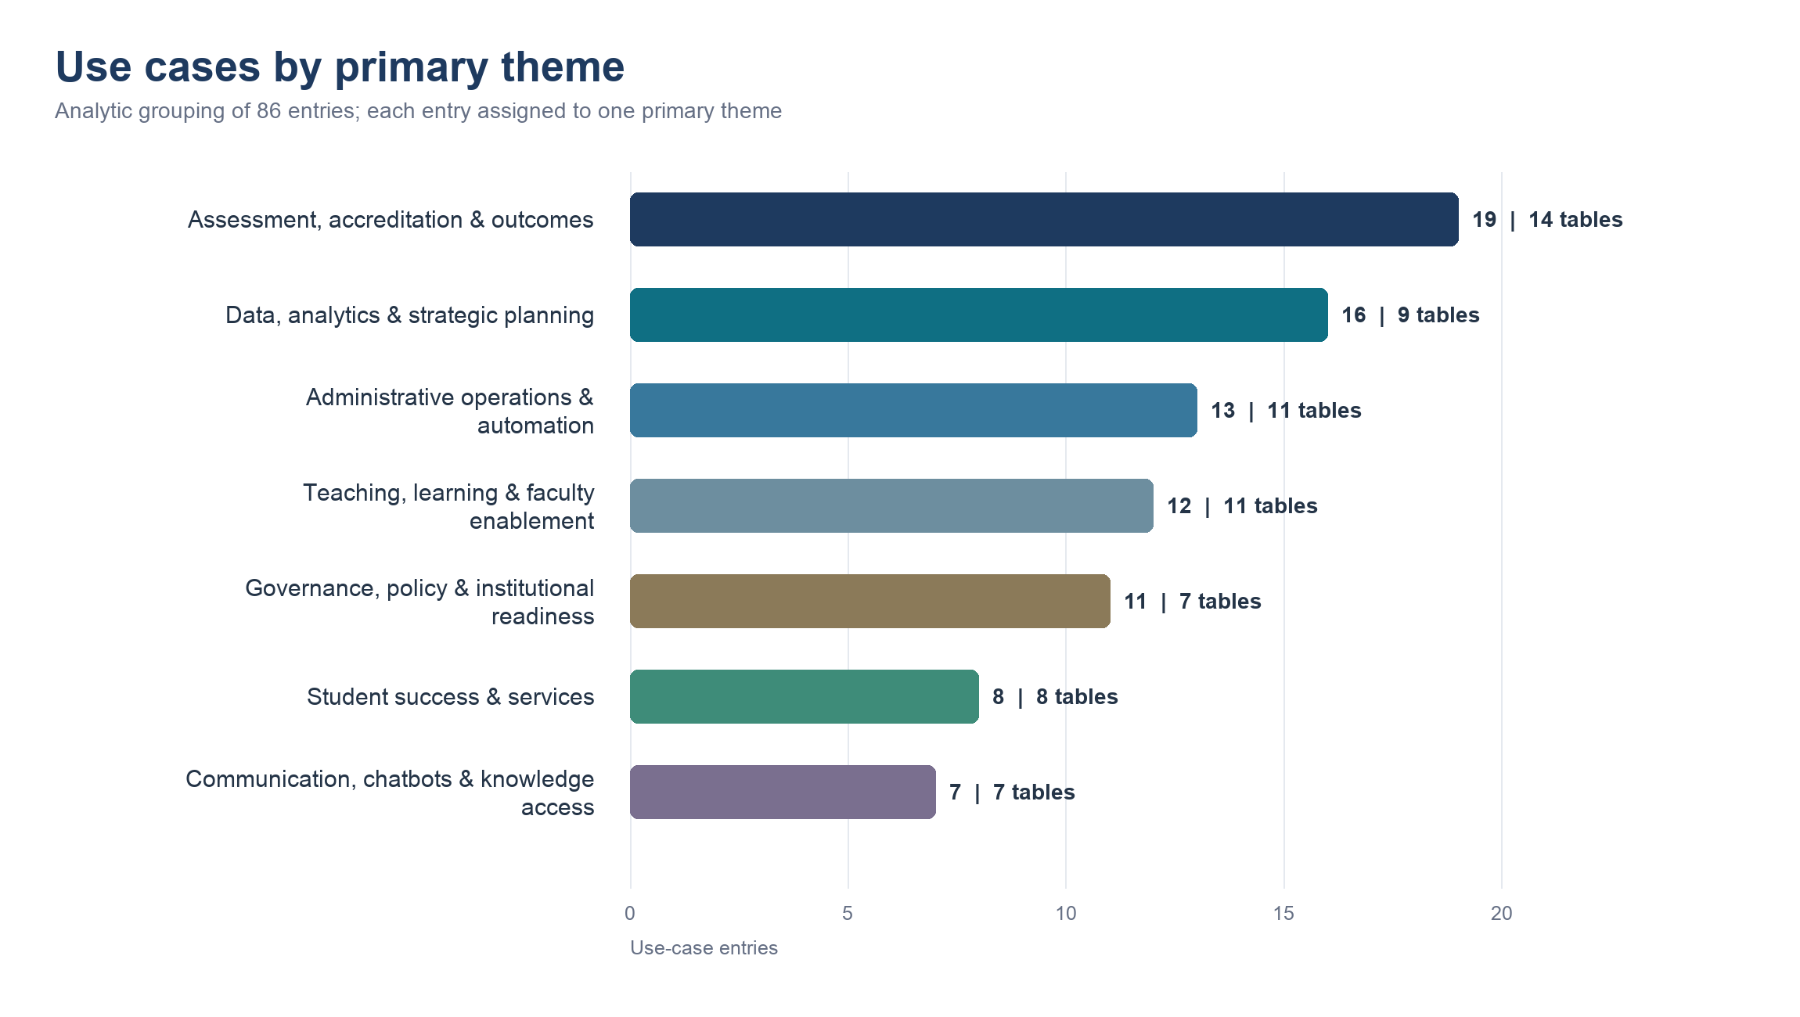
Figure 1. Count of use-case entries by analytic primary theme; labels also show the number of table groups represented.
Source: All Tables Combined worksheet. Themes were assigned analytically for synthesis; they were not participant-provided categories.

Ratings show optimism, with uneven evidence depth
High-value judgments were common where groups completed the ratings. However, feasibility was recorded for only 37 entries and mission alignment for 36. The risk distribution is a meaningful counterweight: 13 of 44 rated entries were High risk, 19 Medium, 10 Low and 2 mixed. The institution should not treat missing ratings as favorable scores.
Criterion | Completed | Observed signal
Value | 45 of 86 | 34 High; 8 Medium; 2 Low; 1 mixed
Feasibility | 37 of 86 | 19 High; 12 Medium; 3 mixed; 3 qualitative
Risk | 44 of 86 | 13 High; 19 Medium; 10 Low; 2 mixed
Mission alignment | 36 of 86 | 21 High; 8 Medium; 2 mixed; 5 qualitative/conditional
Completed counts reflect nonblank worksheet entries. Mixed and qualitative labels preserve participant wording rather than forcing incompatible scales into a single numeric score.

The strongest path is a balanced pilot portfolio
A four-lane portfolio captures the dominant ideas without overconcentrating risk. The lanes below combine the most recurrent concepts with practical guardrails. They are a decision framework for the next round, not a final ranking of individual submissions.
Pilot lane | Representative use cases | Why it matters | Minimum guardrail
Mission assurance | Program outcomes assessment; program review; learning outcomes; accreditation review | Broadest cross-table theme and direct connection to institutional quality | Human academic review; audit trail; version-controlled evidence
Decision intelligence | Survey and trend analysis; dashboards; enrollment/budget forecasting; strategic-plan synthesis | Largest share of explicit top-priority cases | Defined data sources; privacy controls; accountable decision owner
Service and operations | Workflow automation; IT service desk; scheduling; forms/checklists; onboarding | Visible time savings and bounded processes can create early wins | Process owner; exception path; service-quality baseline
Learning and support | Early alerts; student support agents; LMS curriculum tools; ethical-AI assignments | Strong mission alignment with potential student and faculty benefit | FERPA/data minimization; bias review; transparency; accessibility
Source: cross-table synthesis of the aggregated worksheet. Examples are representative and do not replace the complete workbook inventory.

Recommended next steps
- Shortlist and re-score six to eight candidates. De-duplicate similar ideas, retain representation across the four portfolio lanes, and apply one common 1-5 rubric for value, feasibility, risk and mission alignment.
- Add implementation evidence. For each candidate, name an executive sponsor and process owner; identify data sources, approved tools, dependencies, expected time-to-value and affected stakeholders.
- Select two or three 90-day pilots. Favor bounded workflows with usable data, measurable baselines and a human decision-maker. Include at least one mission-assurance pilot and one operational or decision-intelligence pilot.
- Build governance and enablement into the pilots. Define approved uses, data classification, vendor review, human-in-the-loop expectations, accessibility, training and incident escalation before launch.
- Use evidence to scale, revise or stop. At the end of each pilot, review quality, time saved, adoption, equity, privacy/security events and stakeholder experience. Scale only when benefits are repeatable and controls are working.
Suggested 90-day decision gate: advance a pilot only if it has a named owner, approved data path, measurable baseline, human review step and documented stop condition.

Questions leadership should resolve
- Which candidate use cases already have a sponsor, process owner and accessible data?
- Which tools and data classifications are approved today, and where would procurement or security review delay a pilot?
- What baseline metrics will show that a pilot improves quality, service, efficiency or student outcomes without creating unacceptable risk?

Method and limitations
- The analysis covers 86 transcribed poster entries from 22 table groups in the July 20, 2026 Activity 1 session.
- Entries are brainstorming outputs, not fully specified or de-duplicated business cases; similar ideas may appear more than once.
- Ratings were optional or inconsistently expressed. Only 34 entries contained Value, Feasibility, Risk and Mission Alignment together; priority notation also varied by table.
- The seven primary themes were assigned analytically for synthesis, with each entry counted once. Transcription uncertainties remain documented in the source workbook.
Bottom line: The session produced a credible institutional AI opportunity portfolio. The immediate leadership task is to convert the strongest recurring ideas into a small, governed set of measurable pilots - while preserving the human judgment, mission alignment and accountability that participants repeatedly emphasized.
Primary source: Napier_Activity1_Use_Case_Prioritization_Results_20260720.xlsx, All Tables Combined worksheet.

