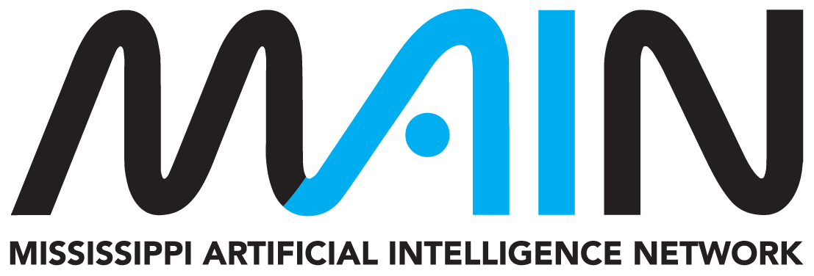
MAIN AI PLAYBOOK IMPLEMENTATION KIT
AI and Dual Enrollment Coordination Toolkit
Working tools for aligning college academic expectations with K-12 technology, privacy, access, and student-support responsibilities.
Audience | Postsecondary institutions, school districts, dual-enrollment offices, instructors of record, facilitators, counselors, IT, privacy, accessibility, students, and families
Edition | Version 1.0 | Reviewed August 2026
Companion resource | https://mainms.org/ai-dual-enrollment-guide/
Purpose: Use this working kit to turn the companion MAIN resource into decisions, records, and repeatable action. Complete only the sections relevant to the proposed use and retain the result under your organization's normal recordkeeping practices.

Important boundary: This voluntary planning resource does not replace applicable law, safety or cybersecurity requirements, institutional policy, contracts, professional standards, or qualified review. MAIN does not approve local tools, uses, or decisions.

1. Partnership and course snapshot

Course record
Field | Local entry
Postsecondary institution
District / school
Course and term
Instructor of Record
K-12 facilitator / coordinator
Students / grade levels
College AI policy
District technology / AI policy
Approved tools and access
Escalation contacts
Known differences or constraints
Academic authority, blocked tools, age/account terms, privacy, accessibility, cost, professional standards, or timing.

2. Local responsibility matrix
Responsibility | Lead | Supporting roles | Evidence / location
Course academic standards and learning outcomes
Assignment-level AI status
Approved tools, accounts, and network access
Student privacy and records
Accessibility and equivalent access
Student orientation and family communication
Faculty / facilitator preparation
Academic-integrity process
Conflict escalation and final authority
Annual review and policy-change communication

3. Institutional readiness
[ ] | Partners have reviewed the current Mississippi dual-enrollment manual and their agreement.
[ ] | Academic authority and assignment-level AI decision rights are clear.
[ ] | Current college and district AI, privacy, security, accessibility, and integrity requirements are available.
[ ] | Approved tools, account types, age limitations, consent processes where applicable, and alternatives are documented.
[ ] | Students receive one clear instruction when institutional requirements differ.
[ ] | Escalation contacts and response expectations are known before the course begins.

Instructor and facilitator readiness
[ ] | Course and assignment AI expectations are communicated before work begins.
[ ] | The learning objective and work students must perform personally are explicit.
[ ] | Facilitators know what they may clarify and what must be routed to the Instructor of Record.
[ ] | AI detection is not treated as sole evidence of misconduct.
[ ] | Privacy, approved tools, accessibility, and equivalent participation have been addressed.

Student and family readiness
[ ] | Students understand college-level authority and how assignment rules may differ.
[ ] | Students know how to ask whether a specific AI use is allowed.
[ ] | Students can verify claims, sources, calculations, code, and disclosure.
[ ] | Students know what information must not be placed in unapproved tools.
[ ] | Families receive appropriate information without confusing record rights or academic authority.

4. Course and assignment templates
Sample course AI statement - adapt locally
Artificial intelligence expectations may vary by assignment. Follow each assignment's AI instructions and ask before using AI when the boundary is unclear. Unauthorized assistance may violate applicable academic-integrity requirements. When AI is authorized, you remain responsible for accuracy, sources, calculations, code, originality, privacy, and the final work. Disclosure or citation requirements will be stated when applicable.

Assignment AI permission card
Field | Local entry
Status | [ ] Required [ ] Permitted [ ] Limited [ ] Prohibited
You may
You may not
Approved tool / alternative
Disclosure / citation
Verification
Learning objective
Questions / contact

5. Conflict-resolution record
Do not ask a student to bypass controls or decide which institution to disobey.

Resolution sequence
Step | Record
Identify | Exact conflict, course or assignment, tool, timing, and affected students.
Pause | Interim instruction that avoids bypassing controls or unfairly penalizing students.
Notify | Instructor of Record, postsecondary office, district/school coordinator, and other designated authority.
Classify | Academic standard, access, privacy/security, conduct, accessibility, cost, contract, or legal/compliance issue.
Resolve and document | Authority, approved path or equivalent alternative, owner, effective period, and communication.
Improve | Course material, onboarding, agreement, or process change needed to prevent recurrence.
Final student instruction
Write the single, clear instruction provided to the student and identify the contact for questions.

6. Annual AI alignment review
[ ] | College and district AI policies and guidance
[ ] | Approved tools, account terms, privacy, security, age, and access
[ ] | Syllabus and assignment language
[ ] | Integrity and detection practices against current evidence
[ ] | Student orientation and faculty/facilitator preparation
[ ] | Accessibility and equitable-access alternatives
[ ] | Contacts, escalation path, and response expectations
[ ] | Partnership agreement, handbook, or operating-procedure updates
[ ] | Communication of material changes to students and families
Annual review decisions
Changes, owners, due dates, effective term, and communication plan.

Reference and review record
Record local reviewers and revisit the kit whenever the tool, data, workflow, policy, or risk changes.
Local reviewers and roles
Names, roles, departments, and dates reviewed.

Local requirements consulted
Policies, contracts, procedures, laws, standards, or regulator guidance that control this use.

Companion MAIN resource
https://mainms.org/ai-dual-enrollment-guide/

Selected authoritative foundations
- Mississippi Institutions of Higher Learning dual enrollment
- Mississippi Community College Board dual enrollment and credit
- U.S. Department of Education FERPA resources
- FTC COPPA FAQs
Maintenance: This is a living implementation aid. Confirm current source status before high-consequence use and record material local changes or decisions.

