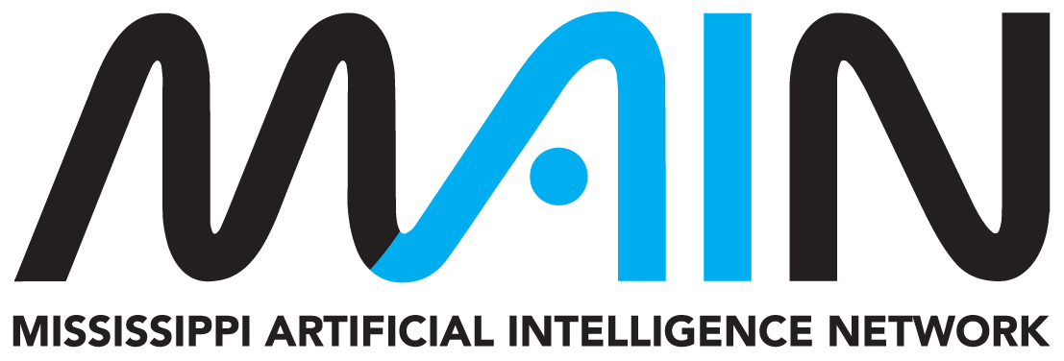
MAIN AI PLAYBOOK IMPLEMENTATION KIT
Faculty AI Playbook Implementation Kit
Copy-ready course language and working tools for setting AI expectations, redesigning assignments, and reviewing AI-assisted work.
Audience | College and university faculty, instructional leaders, academic support, accessibility, libraries, IT, privacy, security, and student-success teams
Edition | Version 1.0 | Reviewed August 2026
Companion resource | https://mainms.org/faculty-ai-playbook/
Purpose: Use this working kit to turn the companion MAIN resource into decisions, records, and repeatable action. Complete only the sections relevant to the proposed use and retain the result under your organization's normal recordkeeping practices.

Important boundary: This voluntary planning resource does not replace applicable law, safety or cybersecurity requirements, institutional policy, contracts, professional standards, or qualified review. MAIN does not approve local tools, uses, or decisions.

1. Course AI decision worksheet
Start with learning outcomes and institutional authority, not with a preferred tool.
Course and learning context
Course, modality, discipline, accreditation or professional constraints, and the learning students must demonstrate.

What students must do independently
Name the knowledge, performance, reasoning, writing, calculation, coding, or judgment that must remain visible.

Where AI may support learning
Identify allowed purposes, approved tools, data limits, verification, disclosure, and alternatives.

Default course posture | [ ] Required [ ] Permitted [ ] Limited [ ] Prohibited [ ] Varies by assignment

Before adopting the course posture
[ ] | The rule aligns with institutional and department policy.
[ ] | The rule supports the learning outcomes rather than convenience alone.
[ ] | Students receive assignment-level clarity before beginning work.
[ ] | Approved tools and prohibited data are identified.
[ ] | Accessibility, cost, account, and equitable-access alternatives are available.
[ ] | Disclosure or citation expectations are teachable and proportionate.
[ ] | The course explains how questions and suspected misuse will be handled fairly.

2. Copy-ready course and assignment language
Course AI statement - adapt and approve locally
Artificial intelligence expectations may vary by activity. Follow each assignment's stated AI status and ask before using AI when the boundary is unclear. When AI is authorized, you remain responsible for accuracy, sources, calculations, code, originality, privacy, and the final work you submit. Do not upload protected, confidential, restricted, or another person's information into an unapproved tool. Disclosure or citation requirements will be stated when applicable.

Assignment AI permission card
Field | Instructor entry
Status | [ ] Required [ ] Permitted [ ] Limited [ ] Prohibited
You may
You may not
Approved tools / alternatives
Disclosure or citation
Verification required
Learning students must perform
Questions / contact

3. Assignment redesign worksheet
Learning outcome
What should a successful student know or be able to do?

Current task and likely AI use
Where could AI support, obscure, or replace the intended learning?

Design options
[ ] | Require visible process such as notes, drafts, calculations, code history, lab records, or source evaluation.
[ ] | Ask students to explain, defend, demonstrate, or reflect on consequential choices.
[ ] | Use authentic course, community, laboratory, field, or local context where it serves the outcome.
[ ] | Ask students to verify, critique, correct, or compare an AI output when AI literacy is itself relevant.
[ ] | Provide an accessible equivalent when a particular tool or account is not essential to the outcome.
[ ] | Use an assignment-specific AI status rather than relying on a vague syllabus sentence.
Revised task and evidence
Describe the revised directions, AI boundary, required evidence, and grading criteria.

4. Faculty AI workflow review
[ ] | The tool and workflow are institutionally approved for the information involved.
[ ] | Identifiable student records, grades, accommodations, unpublished work, and confidential material are not entered without authorization.
[ ] | AI output is checked against course materials, primary sources, calculations, code tests, or qualified expertise.
[ ] | Faculty disclose material AI assistance when students would reasonably need that context.
[ ] | AI does not independently make consequential grading, integrity, accessibility, or student-support decisions.
[ ] | Bias, accessibility, and unequal impact have been considered.
[ ] | Prompts, outputs, revisions, approvals, or other records are retained when required.
Workflow record
Purpose, tool, data, verification, human decision, limitations, and next review.

5. Academic-integrity evidence review
A detector score is not a finding. Follow institutional procedures and review the total evidence.

Fair review sequence
Step | Record
1. Clarify the applicable rule | Course, assignment, tool, permitted steps, disclosure, and timing.
2. Preserve relevant material | Assignment, submitted work, drafts, sources, process records, and communications.
3. Examine substantive evidence | Specific inconsistencies, source problems, process gaps, or other relevant evidence.
4. Talk with the student | Give a fair opportunity to explain the work, process, tools, and understanding.
5. Use the established process | Apply institutional standards, authority, documentation, and appeal rights.
6. Improve future clarity | Revise instructions, assessment design, or orientation if the boundary was unclear.
Case notes
Record facts and required process without treating automated detection as sole evidence.

Reference and review record
Record local reviewers and revisit the kit whenever the tool, data, workflow, policy, or risk changes.
Local reviewers and roles
Names, roles, departments, and dates reviewed.

Local requirements consulted
Policies, contracts, procedures, laws, standards, or regulator guidance that control this use.

Companion MAIN resource
https://mainms.org/faculty-ai-playbook/

Selected authoritative foundations
- U.S. Department of Education AI guidance
- U.S. Department of Education FERPA resources
- NIST Generative AI Profile
- U.S. Copyright Office AI initiative
Maintenance: This is a living implementation aid. Confirm current source status before high-consequence use and record material local changes or decisions.

