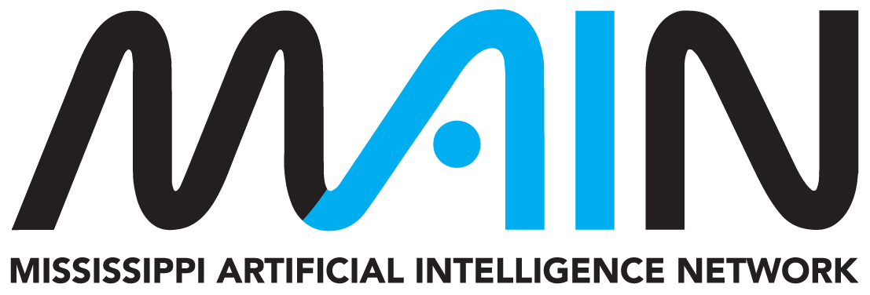
MAIN AI PLAYBOOK IMPLEMENTATION KIT
Student AI Playbook Action Kit
A short, reusable worksheet for deciding whether AI is allowed, using it to learn, checking the result, and disclosing assistance.
Audience | Students in college, university, dual-enrollment, and other postsecondary learning environments
Edition | Version 1.0 | Reviewed August 2026
Companion resource | https://mainms.org/student-ai-playbook/
Purpose: Use this working kit to turn the companion MAIN resource into decisions, records, and repeatable action. Complete only the sections relevant to the proposed use and retain the result under your organization's normal recordkeeping practices.

Important boundary: This voluntary planning resource does not replace applicable law, safety or cybersecurity requirements, institutional policy, contracts, professional standards, or qualified review. MAIN does not approve local tools, uses, or decisions.

1. Can I use AI for this activity?

Assignment check
Question | Your answer
What do the syllabus and assignment say?
What AI status applies? | [ ] Required [ ] Permitted [ ] Limited [ ] Prohibited [ ] Unclear
What tool and specific step do I want to use?
What must I do independently?
What disclosure, citation, or process evidence is required?
Who should I ask if unclear?
Ask precisely: May I use [tool] for [specific step]? If yes, what should I disclose or cite, and what evidence of my own process should I submit?

2. Responsible AI learning plan
My permitted purpose | [ ] Explain [ ] Practice [ ] Brainstorm [ ] Research support [ ] Feedback [ ] Code / data support
My learning goal
What am I trying to understand or practice - not merely finish?

Minimum information I will provide
Remove private, restricted, unnecessary, or another person's information.

My prompt or interaction plan
Ask for explanation, alternatives, questions, critique, or feedback consistent with the assignment rule.

What I will do myself
Identify the reasoning, writing, calculation, coding, evaluation, or final judgment you will perform.

3. Verification and safety check
[ ] | I opened and read every source I plan to use.
[ ] | I checked author, title, date, publisher, and the passage supporting each claim.
[ ] | I recalculated important numbers and checked units and assumptions.
[ ] | I tested code in an appropriate environment, including edge and failure cases.
[ ] | I compared the answer with course materials and credible primary sources.
[ ] | I looked for missing context, stereotypes, unsupported certainty, and contradictory evidence.
[ ] | I did not enter passwords, private messages, health or financial information, exams, answer keys, confidential work, or another person's information.
[ ] | I checked what any connected AI agent can read, change, send, buy, or delete and granted only necessary access.
Errors, limitations, or changes I found
Record inaccurate claims, invented citations, calculation or code errors, bias, missing context, and what you changed.

4. Disclosure builder and before-submit check
Disclosure draft
I used [tool and version, if known] on [date] to [permitted purpose]. I reviewed the output by [verification steps], changed [what changed], and take responsibility for the submitted work. Follow the instructor's required format if it differs.

Before submitting
[ ] | I followed the AI rule for every step.
[ ] | The final work reflects my own understanding and judgment.
[ ] | I can explain the claims, methods, calculations, code, sources, and choices.
[ ] | I did not invent experience, data, results, quotations, or sources.
[ ] | I checked citations, paraphrases, permissions, attribution, and disclosure.
[ ] | I protected private and restricted information.
[ ] | I retained prompts, drafts, or process records the instructor requires.
[ ] | I asked before submitting if any rule remained unclear.
Final reflection
What did AI help you practice? What did you reject or correct? What can you now explain without the tool?

Reference and review record
Record local reviewers and revisit the kit whenever the tool, data, workflow, policy, or risk changes.
Local reviewers and roles
Names, roles, departments, and dates reviewed.

Local requirements consulted
Policies, contracts, procedures, laws, standards, or regulator guidance that control this use.

Companion MAIN resource
https://mainms.org/student-ai-playbook/

Selected authoritative foundations
- Student Guide to AI
- U.S. Department of Education FERPA resources
- CISA Secure Our World
- U.S. Copyright Office AI initiative
Maintenance: This is a living implementation aid. Confirm current source status before high-consequence use and record material local changes or decisions.

